**DAILY ONLINE ACTIVITIES SUMMARY**

|  |  |  |  |  |  |  |  |  |
| --- | --- | --- | --- | --- | --- | --- | --- | --- |
| **Date:** | **23/05/2020** | | | | | **Name:** | **Shwetha** | |
| **Sem & Sec** | **8th B** | | | | | **USN:** | **4AL16CS101** | |
| **Online Test Summary** | | | | | | | | |
| **Subject** | | **-** | | | | | | |
| **Max. Marks** | | **-** | | **Score** | | | **-** | |
| **Certification Course Summary** | | | | | | | | |
| **Course** | **Ethical hacking** | | | | | | | |
| **Certificate Provider** | | | **Great learning** | | **Duration** | | | **6hr** |
| **Coding Challenges** | | | | | | | | |
| **Problem Statement:**  **prob1: Write a c Program to Display first N triangular numbers(Where N is read from the Keyboard)** | | | | | | | | |
| **Status: Solved**  **Solution link: https://github.com/alvas-education-foundation/Shwetha-** | | | | | | | | |
| **Uploaded the report in Github** | | | | | **Yes** | | | |
| **If yes Repository name** | | | | | **Shwetha-** | | | |
| **Uploaded the report in slack** | | | | | **Yes** | | | |

Certification Course Details:

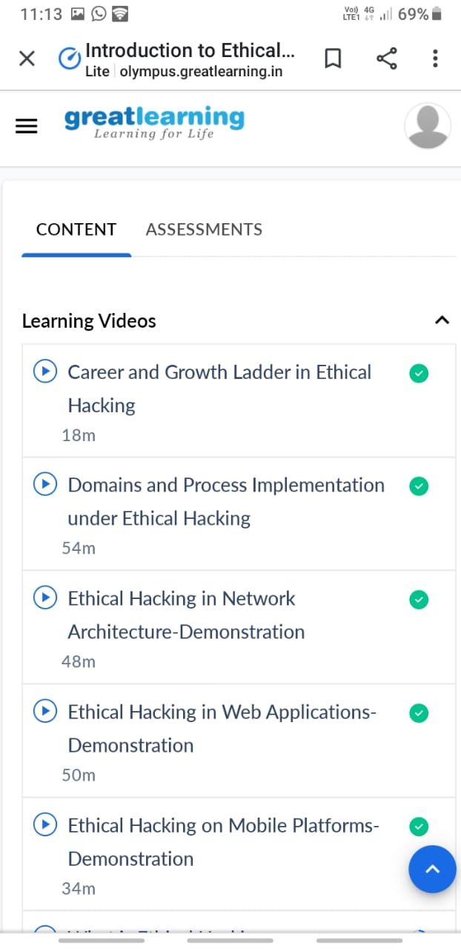

Coding Challenges Details:

Program 1:

#include<stdio.h>

voidtriangular_series(intn)

{

for(inti=1;i<=n;i++)

printf("%d",i*(i+1)/2);

}

intmain()

{intn;

printf("Entervalueforn");

scanf("%d",&n);

triangular_series(n);

return0;

}